SCUBA 2 data acquisition software overview
Part two protocols

Summary
The purpose of this document is to provide detailed protocol for the communication between SCUBA2 data acquisition software and the Bolometer Array Controller (BAC). It is a preliminary description of the protocols. Some of the items (eg interaction between START APPLICATION and STOP APPLICATION, and specification of meaning of status bits) have still to be finalised between the firmware and software implementers.

References
[1]” Data Link protocol.doc”, Michael MacIntosh. UK Astronomy Technology Centre
[2] /tmp/lo/0000.doc”, Chris Tierney, David Atkinson, Derek Ives, Steven Beard
UK Astronomy Technology Centre
[3]” SCUBA-2 Data Acquisition to Data Processing Interface”, Dennis Kelly. UK Astronomy
Technology Centre

Introduction
The approach to the design of the SCUBA2 data acquisition software is to reuse as much as possible of WFCam / Ultracam low level software developed at ATC so that the overall effort both in designing and maintaining can be largely saved by ATC (UK) and JAC (Hawaii). The common data acquisition layer for all three instruments is illustrated in Figure 1. They all use the Linux Operation system on a PC with the kernel modified to utilise the real-time Linux RTLinux from RTAI.
(http://www.aero.polimi.it/RTAI/rtai-24.1.13.tgz ) . The communication between the data acquisition computer and the Bolometer Array Controller (BAC) is done through a SDSU PCI card with 200Mbits/s optic fiber. However, there are differences among these instruments, which inevitably lead to changes being made to our design. In the next sections, we outline the protocol used by the SCUBA2 in detail.

Controller

PC
250MHz fiber
Linux
RTLinux
PCI interface
(DSP or FPGA)

Figure 1 The low level data acquisition layer

The SCUBA2 low level protocol

As mentioned in section 3, we want to reuse as much as possible of the WFCam/Ultracam low level software, i.e. try to keep our protocol very similar to that used for WFCam/Ultracam. For SCUBA2, the data coming out of the controller will be in 32-bit format (But, in engineering mode, data may be in 16-bit format). For simplicity, the BAC must always send data in multiple of 4 bytes (32-bit). In order to make the protocol (see later) work, we first specify the operation of the SCUBA2 BAC.

All the commands and data sent to the BAC from the RTL PC are in Little-endian format, it is expected that all replies and data received from the BAC by the RTL PC are in Little-endian format.

The BAC operation principles
The BAC will consist of several cards, including clock and control cards. Its communication to the SCUBA2 data acquisition system is achieved through a single bi-direction 250MHz optical fibre. There will be a buffer area on the control board where data arriving at the fibre receiver is passed on. A hardware flag shall be available to signal to the control chip (FGPA) that unread data has been placed in the FIFO. The FPGA must accept commands on its fibre in a standard format (see section 5.2). There will also be a large buffer area for holding several array data frames. The data sent back to the data acquisition system could be derived from two sources: reply to commands and data for array readout. All packets of data originating from the BAC, whether command reply or frame data, must be preceded with a header, which indicates: in which mode (reply or frame data) the data in the following packet is transmitted and the length of the packet.

To reliably distinguish the commands (BAC received) or the headers/replies (data acquisition system received, PCI DSP) from corrupted data, a special preamble or synchronisation of two 32-bits words shall be used, i.e. all commands to the BAC and all replies/ frame data from the BAC shall be preceded with the preamble words. In SCUBA 2, the frame data can in principle be any 32-bit (4 bytes) value. However, it is expected that the average of the data values returned will change only slowly as the sky background changes and that there will be no large changes from one data value to the next. Therefore, two 32-bit words, which are the logical inverse of one another, shall be adequate for the preamble. For added robustness, a checksum shall be added.

The BAC must generate a standard format reply upon commands implemented, with the exceptions: “reset” and "start_application", which generate replies before execution. Such standard replies indicate success or failure of the command.

Upon receiving a “start_application” command, the BAC begins to execute the current application. The possible thing for the BAC to run the application would simply set a bit in its special register or send back a block of data (frame data) from particular address. Until completion of this application, the only valid command that may be sent to the BAC is “stop_application”. So_called “on-the-fly” modification or examination of parameters is not allowed. The change of bias level can only be carried out while the BAC is not running the application. If the STOP command is received while the BAC is running an application, then the next frame sent back will have the 'last frame' flag set (i.e. bit 0), and also the 'stop' flag set (i.e.bit1) in the frame status word, thereby indicating a forced stop. After sending the last frame, the BAC replies to the STOP command. The rule is that NO reply to a BAC command should be sent to PCI in the middle of a data packet.

It is required that applications can be either downloaded onto the BAC by host software or loaded locally (here, it may just be to set a bit). All applications reside at a defined start address in on-board memory, the first word of which must contain an identifier that is unique to each version of application code. Due to the programming nature of FPGAs, new FPGA configuration files will be downloaded from the RTL PC into SRAMs on the BAC boards, then FPGAs are programmed locally inside the BAC by issuing a command from the RTL PC.

Applications should be structured such that they maintain a “parameter block” – a contiguous memory block that contains all parameters related to the application. Values in this parameter block may be modified by the host software before “start_appication”. However, values in this block must not be modified by the running application – rather, the application makes working copies of the parameters as required. In this way, it will be possible for the user to ask for a repeat execution of an application with unchanged parameters.

Figure2 demonstrates simply the command and reply/data flowchart for the BAC, and Figure3 shows the command and reply flowchart for the PCI. The detailed protocols are described in the next section.

Commands(WRITE, WRITEBLK, READ, READBLK STOP)→PCI →BAC→Execution→Reply→PCI→host

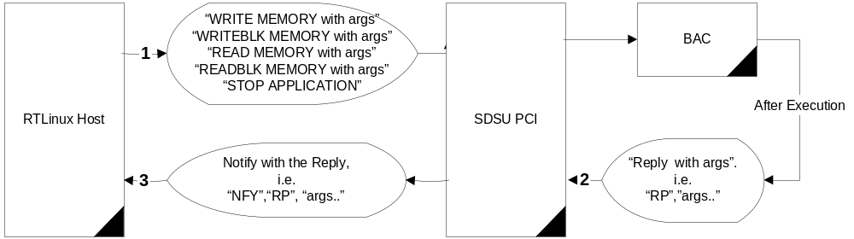

Command (START,RESET)→PCI →BAC→before Execution→Reply→PCI→host

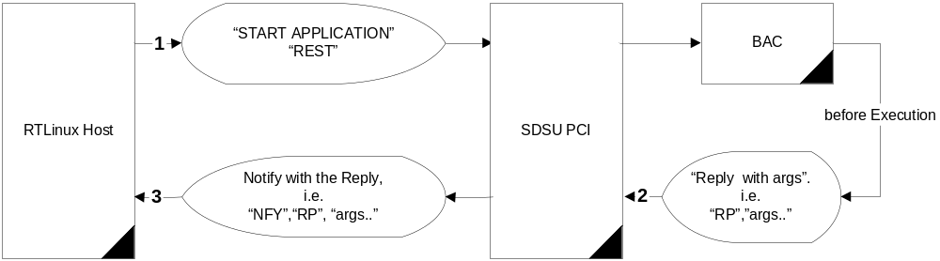

BAC: after acknowledge of the START command→data→PCI→host
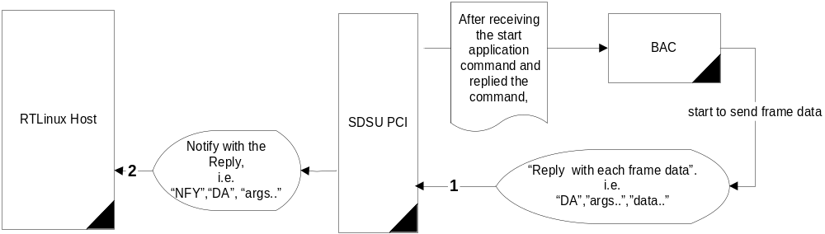

Figure 2. The command and reply/data flowchart (BAC)

Command→PCI→Execution→Reply→host
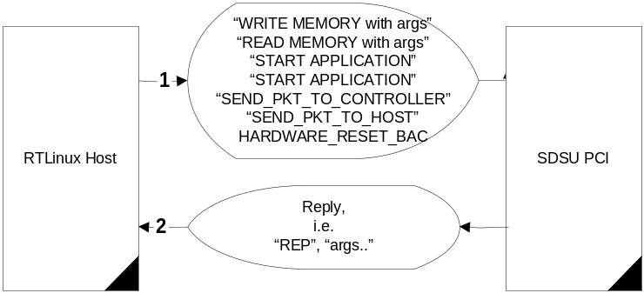

Figure 3. The command and reply flowchart (PCI)

The commands to the BAC

A). The commands apart from the Write block memory
TABLE 1
Preamble  (2 X 32 bits) |  | Command  (32bit ) |  | Card address  (8 bit) | Memory address  (24 bit) |  | Data  (32bit) |  | Checksum  (32bits)
0xA5A5A5A5
0x5A5A5A5A
Word1/word2 |  | Word3 |  | Word4 |  |  | Word5 |  | Word6
The standard commands are:
Write_memory | “ WM”  0x2020574D |  | Card+Address |  |  | Value |  | Xxxx
Read_memory | “ RM”  0x2020524D |  | Card+Address |  |  | 0x00000000 |  | Xxxx
Start_application | “ GO”  0x2020474F |  | Card+Address |  |  | Identifier |  | Xxxx
Stop_application | “ ST”  0x20205354 |  | Card+Address |  |  | Dummy |  | Xxxx
Reset | “ RS”  0x20205253 |  | Card+Address |  |  | Dummy |  | Xxxx
Read_block memory  (not finalised) | “ RB”  0x20205242 |  | Card+startAddress |  |  | No of data (max=63) or dummy |  | Xxxx

B). The Write block memory command

Preamble  (2 X 32 bits) |  | Command  (32bit ) |  | Card address | Memory address |  | Number of  Data |  | 58 Data  (32bit) |  | Checksum  (32bit)
A5A5A5A55A5A5A5A
Word1/word2 |  | Word3 |  | Word4 |  |  | Word5 |  | Word6~word63 |  | Word64
The standard commands is:
Write_block memory  (not finalised) | “ WB”  0x20205742 |  | Card+startAddress |  |  | Xxx |  | Xxxx |  | Xxxx

Each command is preceded with the preamble of $A5A5A5A5 5A5A5A5A and ended with the checksum. The checksum (word6, initial=0) use XOR method, i.e. word6=word3 XOR word6; word6=word4 XOR word6; word6=word5 XOR word6, and so on.

The reply (BAC->PCI) for command and data for frame array readout

A). The reply for commands apart from the Read Block memory command
TABLE 2
(2X32 bits)  Preamble | (32 bit) | (32 bit) | (32 bit) | (32 bit) | (32 bit)
0xA5A5A5A5  0x5A5A5A5A | “ RP”  0x20205250 | Packet size | Reply | Reply argument | Checksum
Header1/2 | Header3 | header4 | Word1 | Word2 | Word3
The packet size counts in Number of 32-bit (4 bytes) words. The Header1, 2, 3 and 4 are only seen by the PCI DSP, not the RTL software.
The expected rely will be:
 | Success reply |  | Failure reply
 | Word 1 | Word2 | Word 1 | Word 2
Write_memory | “WMOK”( 0x574D4F4B) | 0x00000000 | “ ER”( 0x20204552) | Errno
Read_memory | “RMOK”( 0x524D4F4B) | Value | “ ER”(0x20204552) | Errno
Start_application | “GOOK“( 0x474F4F4B) | 0x00000000 | “ ER”(0x20204552) | Errno
Stop_application | “STOK”( 0x53544F4B) | 0x00000000 | “ ER”(0x20204552) | Errno
Reset | “RSOK” ( 0x52534F4B) | 0x00000000 | “ ER”(0x20204552) | Errno
Write_Block memory | “WBOK” ( 0x51424F4B) | 0x00000000 | “ ER”( 0x20204552) | Errno

The checksum (word3, initial=0) use XOR method, i.e. Word3=word1 XOR word3; word3=word2 XOR word3.

B). The reply for “RB”
Preamble(2X32 bits) | (32 bit) | (32 bit) | (32 bit | (32 bit) | (32 bit)
0xA5A5A5A5  0x5A5A5A5A | “ RP”  ( 0x20205250) | Packet size | Reply | 62 Reply data (fixed) | Checksum
Header1/2 | header3 | header4 | Word1 | Word2~63 | Word64

The expected rely will be:
 | Success reply |  | Failure reply
 | Word 1 | Word2~word63 | Word 1 | Word 2
Read_Block memory | “RBOK” ( 0x52424F4B) | Value | “ ER” (0x20204552) | Errno

The checksum (word63, initial=0) use XOR method, i.e. Word63=word1 XOR word63; word63=word2 XOR word63…. So on.

C).The data for frame array readout
TABLE 3
(2X32 bit)  Preamble | (32 bit) | (32 bit) | (N x 32 bits)  Frame data |  |  | (32bit)
0xA5A5A5A5  0x5A5A5A5A | “ DA”  0x20204441 | Packet size | Frame status | … | … | Checksum
Header1/2 | Header3 | Header4 | Word1 | Word2 | … | WordM
The packet size counts in Number of 32-bit (4 bytes) words
The checksum (wordM, initial=0) use XOR method, i.e. WordM=word1 XOR wordM; wordM=word2 XOR wordM…. So on.

Each bit in the frame status represents a certain condition. For example, if bit_X is set, then the data will be in 16 bit format, otherwise, it will be in 32 bit format. The bit definition of the frame status will be finalised later. The frame status will be read by the host. The possible frame data will be [3]

frame
{
frame header
{
INT32 frame number
INT32 column count
INT32 system status
INT32ARRAY status info
}
column
{
….
}
more columns as necessary
::
frame footer
{
INT32 endframe tag
}
}

4.4 The commands to the PCI board (four 24-bit words):
We will keep the commands and replies for the PCI board the same as those defined in Ultracam with one exception: CON
The argument 3 of CON is defined as: 1 for WB; 0 for the rest. When the PCI see the argument of 1, it shall change to DMA Burst mode to get the data from memory.

TABLE 4
 |  | Command  (24 bit) | Argument 1  (24 bit) | Argument 2  (24 bit) | Argument 3  (24 bit)
 | The format for each command is as follows:
Write_memory |  | WRM | Memory type | Address | value
Read_memory |  | RDM | Memory type | Address | dummy
Start_application |  | GOA | Identifier | Dummy | dummy
Stop_application |  | STP | Dummy | Dummy | dummy
Reset |  | RST | Dummy | Dummy | dummy
Send_packet_to_BAC |  | CON | Buffer addr hi | Buffer addr lo | 1 for WB; 0 for the rest
Send_packet_to_host |  | HST | Buffer addr hi | Buffer addr lo | dummy
Hardware_Reset_BAC |  | RCO | dummy | dummy | dummy

Start_application – start an application on the PCI card's DSP, not the BAC board
Stop_application – stop an application on the PCI card's DSP, not the BAC board
send_packet_to_BAC – instruct the PCI card to forward a packet of data to the outgoing fibre link.
This packet must be retrieved by the PCI interface, from host memory.
send_packet_to_host – instruct the PCI card to send a packet of data over the PCI bus, into memory
accessible to the host software.
receive_packet – this “command” is never called by the host software. It is, in fact, a
background process that is constantly looking for incoming data on the fibre
link. When data arrives, it is streamed to a buffer in on-board memory. Once
a full packet has been stored, the host is notified that a packet awaits delivery.
The host will respond by causing execution of the send_packet_to_host
command, shown above.
Hardware_Reset_BAC-instruct the PCI card to send a special character to the BAC, which is
Hardware decoded to reset the whole BAC .

4.5 The reply from the PCI card to the Host

The reply for every command comprises four 24-bit words:
TABLE 5
Word 1 | word 2 | Word 3 | Word 4
Reply/notify | CMD copy | Reply word | Data word

The first word is a flag, indicating that this packet of data is a command reply from PCI card or notification from the BAC board

4.5.1 The reply from the PCI card
Reply/Notify = 'REP'
TABLE 6
Word 1 | Word 2 | Word 3 | Word 4
‘REP’ | CMD copy | Reply word | Data word

Replies are of two types, indicating either the success or failure of a command:

TABLE 7
 | Success reply |  | Failure reply
 | Word 3 | Word 4 | word 3 | Word 4
Write_memory | “ACK” | Dummy | “ERR” | Error no.
Read_memory | “ACK” | Value | “ERR” | Error no.
Start_application | “ACK” | Identifier | “ERR” | Error no.
Stop_application | “ACK” | Dummy | “ERR” | Error no.
Reset | “ACK” | Dummy | “ERR” | Error no.
Send_packet_to_controller | “ACK” | Dummy | “ERR” | Error no.
Send_packet_to_host | “ACK” | Dummy | “ERR” | Error no.

4.5.2 The notification from the BAC board
Reply/Notify = 'NFY'.

All communication data from the BAC arrives at the PCI as packets, the PCI DSP must perform an operation termed notify_host (NTY). The NFY command indicates the size of the packets (number of 32-bit words)
TABLE 8
Word 1 | Word 2 | word 3 | Word 4
‘NFY’ | Header3 | header 4(31-16 ) | Header4(15-0)

The first word is a flag indicating that this is not a command reply from the PCI but a notification of data packets received from the BAC. The next three words comprise the header3, header4’s bits of 31 to 16 bit and header4’s bits of 15-0 from TABLE 2 or TABLE 3, as received, thus informing the host of the mode and quantity of words in the packet.

4.6 The handling of corrupted frames by the PCI DSP
The DSP on the PCI card is responsible for checking the frame synchronisation. Once an out of synchronisation occurs, the DSP shall
1). discard the rest of the data until it sees the preamble again.
2). Count frames received from the BAC and record it in order for the high level software to
examine when a frame missing is occurred.

